 | Cape Vintage Motorcycle Club  36th Fairest Cape Tour  6th & 7th November 2023 | 

SUPPLEMENTARY REGULATIONS

These Supplementary Regulations require to be read in conjunction with the SAVVA VSR’s - Please ensure that you are familiar with them. Copies are available from your Club.

1. NATURE AND NAME OF EVENT: A restricted event known as the 36th FAIREST CAPE TOUR 2023

2. DATE OF EVENT: Monday 6th and Tuesday 7th November 2023.

3. DESCRIPTION OF EVENT: A Reliability and Regularity Trial over a total distance of approximately 600 Kms.
The event will start at 07h00 on Monday 6th November 2023 from Goudini Spa, Rawsonville and finish at about 16h00 on Tuesday 7th November 2023 at Goudini Spa, Rawsonville.

4. PROMOTERS: Cape Vintage Motorcycle Club, P.O. Box 107, Bergvliet 7129.

5. JURISDICTION: Held under the International Sporting Codes of the Federation Internationale de l’Automobile (FIA) and/or the Federation Internationale Motorcycliste (FIM), The General Competition Rules (GCR’s) of Motorsport South Africa (MSA), the Standing Supplementary Regulations (VSR’s) of the Southern African Veteran and Vintage Association (SAVVA) as amended January 2009 and these Supplementary Regulations (SR’s).

6. SAVVA PERMIT NO.: To be advised.

7. OFFICIALS: SAVVA STEWARD: Mr. Len Harrison
CLUB STEWARD: Mr. Eddie Kirkwood
CLERK OF THE COURSE: Mr. Gavin Allison
CHIEF MARSHAL/SCORER Mr. Gavin Allison
TROPHY OFFICER Mrs. Janet Allison
EVENT SECRETARY /TREASURER Mr. Eddie Kirkwood

8. ELIGIBILITY: (See VSR’s 8, 10(b) & (c) and 14). Open to members of any club affiliated to SAVVA or a Club or Association registered with Motorsport South Africa, driving motor vehicles, motorcycles, combinations and/or 3 wheelers manufactured on or before 31st December 1997 and having proof of dating by SAVVA.
( See VSR’s 13, 16 & 19 ) All Competitors are required to carry a GPS Data Logger whilst participating on the rally route

9. ENTRIES: (See VSR’s 10 & 11). The official entry form is attached. Entries open immediately and all entries must be emailed to : fairestcapetour@gmail.com . Entries must reach us not later than 22nd October 2023 together with the entry fee as set out on the Entry Form and all other fees as detailed on the Financial Form attached. All Fees in the name of ‘Fairest Cape Tour’ must be paid directly into Nedbank Tygervalley account 1039031587, Branch code 103-910. The minimum number of entries is 35 for the Fairest Cape Tour.

10. METHOD OF SETTING SPEEDS: (See VSR 24). Speeds will be set in accordance with Method 1 as defined in VSR 24(a). A choice of the following speed groups is offered on the entry form:

Score Group A:
Group A - Max 50kph; Group B - Max 60kph; Group C - Max 70kph; Group D - Max 80kph;

Score Group B: (Touring Class/Follow-On:
Group A - Max 50kph; Group B - Max 60kph; Group C - Max 70kph; Group D - Max 80kph;

11. COMPETITION NUMBERS AND STARTING TIMES: (See VSR 16). Competition numbers will be supplied by the organizer. The numbers will be on discs, 225mm in diameter. Backing plates must be provided by the entrant. Competition numbers shall be displayed as per VSR 16(f). The headlights must not be obstructed by the competition number nor may the numbers be covered with clear vinyl. Numbers and starting times will be advised in the Final Instructions.
12. Competition numbers and starting times will be advised in the final instructions (See VSR 6 (c) ) Competition numbers will be displayed in accordance with VSR – 16 (f).

13. PASSENGERS: (See VSR 19)

14. PRE-START REQUIREMENTS: ( See VSR’s 12 & 17)
In addition to VSR12 (a -p )
A GPS Logger, to be carried by the Competitor, is to be presented to the Chief Scorer at documentation, or as required in the Final Instructions. The instrument must be compatible with the software utilized by the organizers of the event. The onus is on the Competitor to ensure that the battery is charged and that the GPS Logger is in working condition.

15. PRE-START SCRUTINY AND DOCUMENTATION: (See VSR’s 15 & 20). Competitors are required to report for Documentation and Scrutineering at the Rally Headquarters at Goudini Spa, Rawsonville at a time and venue which will be advised in the Final Instructions. Please note that VSR 12 will be strictly applied.

All cars must have fire extinguishers. Please note that cars manufactured prior to December 1945 will require a safety triangle with a red light in the middle of the triangle which must not flash, as per image below:
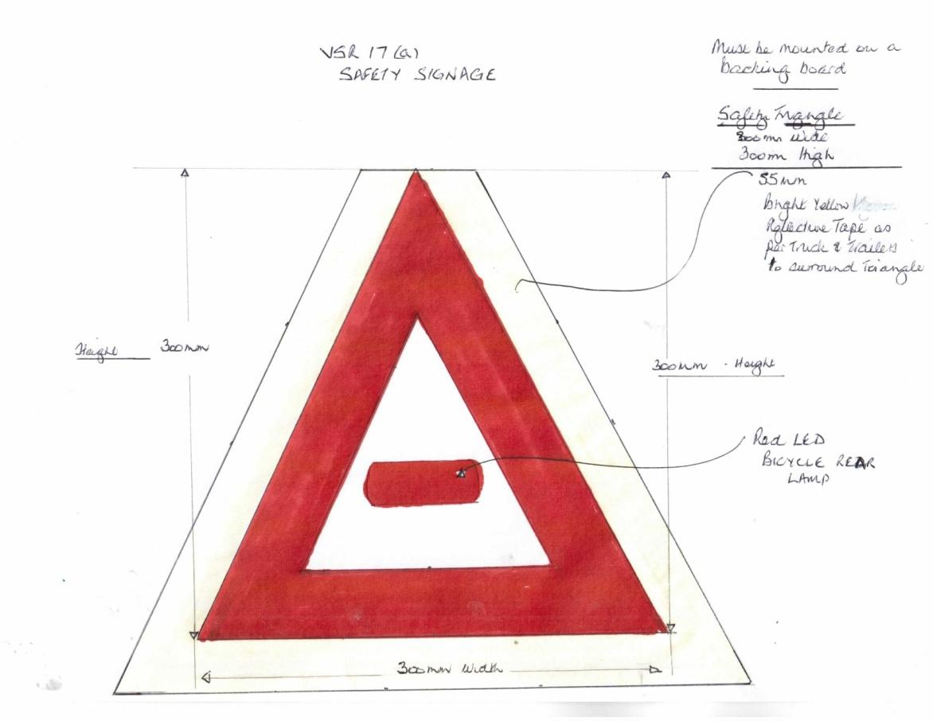

All motorcycles are required to have a white light at the front of their machines as well as a non-flashing red light at the rear of the machine. If their machines were not fitted with a brake light as original equipment, this is not necessary.

16. ROUTE SCHEDULES: (See VSR 21). Route schedules, as per VSR 21(b), will be pre-calculated and will be issued to competitors after Documentation has been completed to the satisfaction of the Organizers. Attention is drawn to VSR 21(d).

17. TIME KEEPING AND CONTROLS: (See VSR’s 26, 27 and 28).
Sealed watches will not be required. Only stop watches and non-programmable clocks may be used. No other measuring instruments or navigational aids (e.g. GPS) may be used.

The OFFICIAL time to be used on the event will be that appearing on the MASTER CLOCK set by the Organizers.
VSR 26 (a) is deleted and replaced by the following:

Open Controls, Secret Controls and Other Controls will be used on the route.

18. RESULTS: (See VSR 29)
VSR 29 (b) is replaced by the following:

After a competitor has presented his/her tracking device to the Chief Scoring Officer, the Chief Scoring Officer will present
The competitor with a detailed Score Sheet – for the control points scored. This report will include a Date/Time/Stamp,
and the competitor will then have thirty (30) minutes to lodge an objection.

Thirty (30) minutes after the last competitor has received his/her detailed score sheet, and if no individual objections have
been received, the Overall Provisional Results will be posted, and will become final thirty (30) minutes thereafter.

Provisional Results will then be announced as soon as possible after 19h00 on Tuesday th^{th} November 2023 at the
Prizegiving event, to be held at the Slanghoek Restaurant.

19. PROTESTS: (See VSR 30)

20. SCORING: (See VSR 28)

VSR 28 (d) is amended to read:
Any competitor receiving maximum penalty points at two thirds of the controls scored, or not arriving at the final control,
and handing in his/her tracking device to the Chief Scoring Officer within 30 minutes of his/her ETA will
be considered a non-finisher for the purposes of the official results of the regularity part of the event.
The Clerk-of-the Course may at his/her discretion, present finishers’ awards to the participants who complete the
entire course in compliance with the reliability part of the event.

21. PENALTIES: (See VSR 33)

22. POSTPONEMENT OR CANCELLATION: (See VSR 9)

23. Competition License: A member in possession of a current valid membership card of any SAVVA affiliated club or
MSA affiliated club is deemed to be in possession of a Restricted Competition License, which mentions affiliation to SAVVA and has the inclusion of a Restricted Competition Licence. The Restricted Competition Licence is valid for SAVVA authorized events as well as for events hosted by MSA associated clubs requiring a Restricted Competition Licence.
For this event, it is required that the vehicle entered be dated by SAVVA and a Dating Certificate issued. Alternatively, the entrant should submit adequate proof that the vehicle complies with the eligibility conditions of entry.

24. COMPETITORS MEETING: Time and venue will be advised in the Final Instructions.

25. INSTRUMENTS: (See VSR 18) The Organizers decision regarding the adequacy of masking shall be final.

26. CLASSES, TROPHIES AND AWARDS – 36th FAIREST CAPE TOUR:

The following Floating Trophies will be awarded at the discretion of the organizers:

OVERALL & CLASS TROPHIES

1st Overall Lowest total score for the event Vic Proctor Trophy
2nd Overall Lowest total score on Day 1. Banzai Trophy
3rd Overall Lowest total score on Day 2. Paul Malcolm Memorial Trophy

Vintage: 1919 - 1930 | Post Vintage: 1931 - 1945 | Post War: 1946 - 1960 | Classic: 1961 - 1993
1st: SAVVA Trophy | 1st : Baby Scott Trophy | 1st: VMC Trophy | 1st: Classic Shield
Please note that the overall winners on the 36th Fairest Cape Tour are not eligible for class awards but are eligible for general trophies for specific achievement.

GENERAL TROPHIES FOR SPECIFIC ACHIEVEMENT - ALL VEHICLES

Best Performance by a 1st Time Entrant. Alf Dolt Trophy
Best Performance by a CVMC Entrant. Nedbank Shield
Youngest Entrant to complete the course. Dave Sansom Trophy
Best Performance by the Oldest Entrant to complete the course. Bill Smith Trophy
Best Performance by a Lady Entrant.
Entrant considered to have had the most problems. Hard Luck Trophy
Best Nominated Team of 3 Entrants. Alan Birch Memorial Trophy

GENERAL TROPHIES FOR SPECIFIC ACHIEVEMENT - MOTORCYCLES ONLY

Best Performance by a Rider/Driver & Pillion/Passenger. Hoffman Trophy
Rider who rode the longest distance to the start.
Clerk of the Course Trophy.

The abovementioned Floating Trophies remain the property of the Cape Vintage Motorcycle Club.

27. FINISHERS’ MEDALLIONS: Personalized Medallions will be awarded to all entrants who participated in the event..

